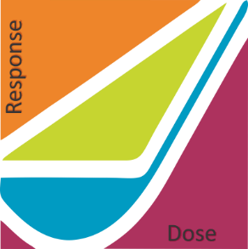American Nuclear Society - Health Physics Society

Applicability of Radiation - Response Models

to Low Dose Protection Standards:

Program Committee Meeting

Tuesday February 27, 2018

Tony Brooks, Steve Baker, Wanda Munn met in Steve’s office with Wayne Glines and Alan Waltar on the phone to discuss recent developments affecting the program.

Two topics were addressed:

* Response to the proposal from Barrett Fountos, U.S. Department of Energy to include epidemiological analysis of Russian exposure data, and
* Approach to including Fukushima Dialog presentations.

Alan contacted Nolan Hertel, Current President, Health Physics Society to solicit his help. Nolan agreed to Co-Chair the Program Committee.

Tony and Wayne will contact Barrett to work out an approach for including the Russian epidemiological presentation.

Barrett Fountos phone number 301-903-6740.

Fukushima Dialog discussion centered around having Ryoko Ando be involved in communications presentations and the entire ICRP delegation be involved in the final discussions.

Next meeting Tuesday 6 March 2018 in Steve’s office.